**DAILY ONLINE ACTIVITIES SUMMARY**

|  |  |  |  |  |  |  |  |  |
| --- | --- | --- | --- | --- | --- | --- | --- | --- |
| Date: | 30/05/2000 | | | | | Name: | Jyothi B R | |
| Sem & Sec | IV-A | | | | | USN: | 4AL18CS030 | |
| Online Test Summary | | | | | | | | |
| Subject | | Data Communication and Maths | | | | | | |
| Max. Marks | | 27 , 30 | | Score | | | 30 ,30 | |
| Certification Course Summary | | | | | | | | |
| Course | Programming Essentials in Python | | | | | | | |
| Certificate Provider | | | Cisco Virtual Academy | | Duration | | | 2.5hrs |
| Coding Challenges | | | | | | | | |
| Problem Statement. String using c. | | | | | | | | |
| Status:Completed | | | | | | | | |
| Uploaded the report in Github | | | | | Yes | | | |
| If yes Repository name | | | | | https://github.com/alvas-education-foundation/jyothi_b_r | | | |
| Uploaded the report in slack | | | | | Yes | | | |

Online Test Details: (Attach the snapshot and briefly write the report for the same)

Certification Course Details: (Attach the snapshot and briefly write the report for the same)

Coding Challenges Details: (Attach the snapshot and briefly write the report for the same)

ONLINE TEST DETAILS:

1. Data Communication

The online test was from module 3 and module 4. There were 30 questions which contains 30 mcq questions and the duration were 30 minutes. The questions were optimal and easy. The score that I received was 27/30.

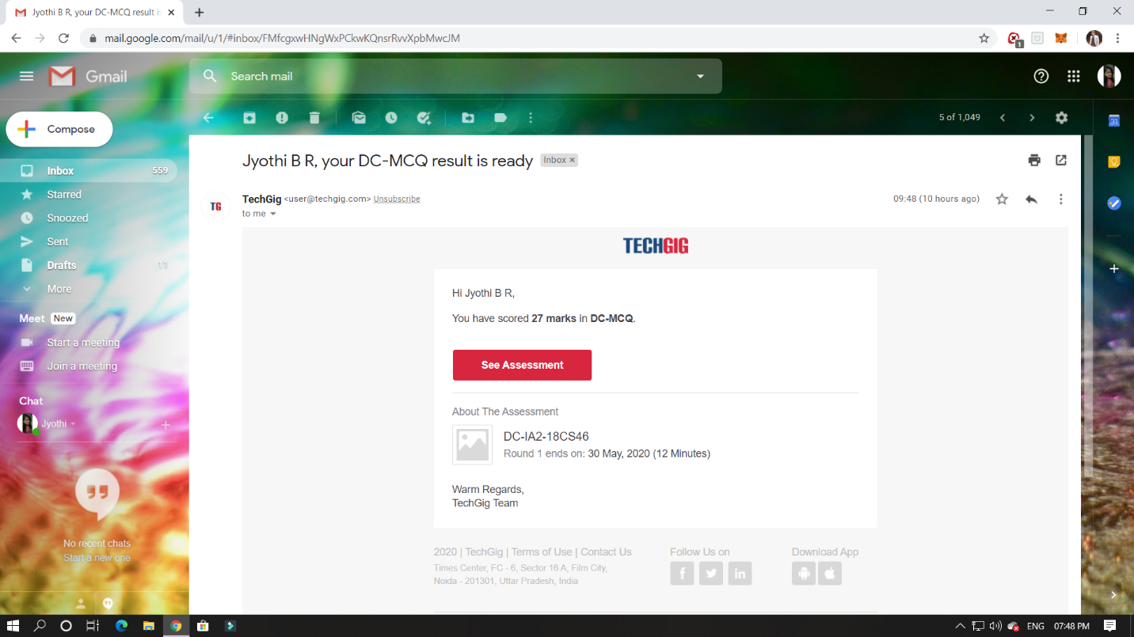

1. Maths

The online test was from module 3. There were 20 questions which contains 10 mcq for 1 mark and 10mcq for 2 mark questions and the duration were 40 minutes. The questions were optimal and easy. The score that I received was 30/30.

**Snappshot :- not taken**

CERTIFICATION COURSE DETAILS:

Programming Essentials in Python :

**Parametrized functions**

The function's full power reveals itself when it can be equipped with an interface that is able to accept data provided by the invoker. Such data can modify the function's behavior, making it more flexible and adaptable to changing conditions.

In this class it says about how to define the function and parameters. Which is used to initialise the value inside and outside the parantheses.

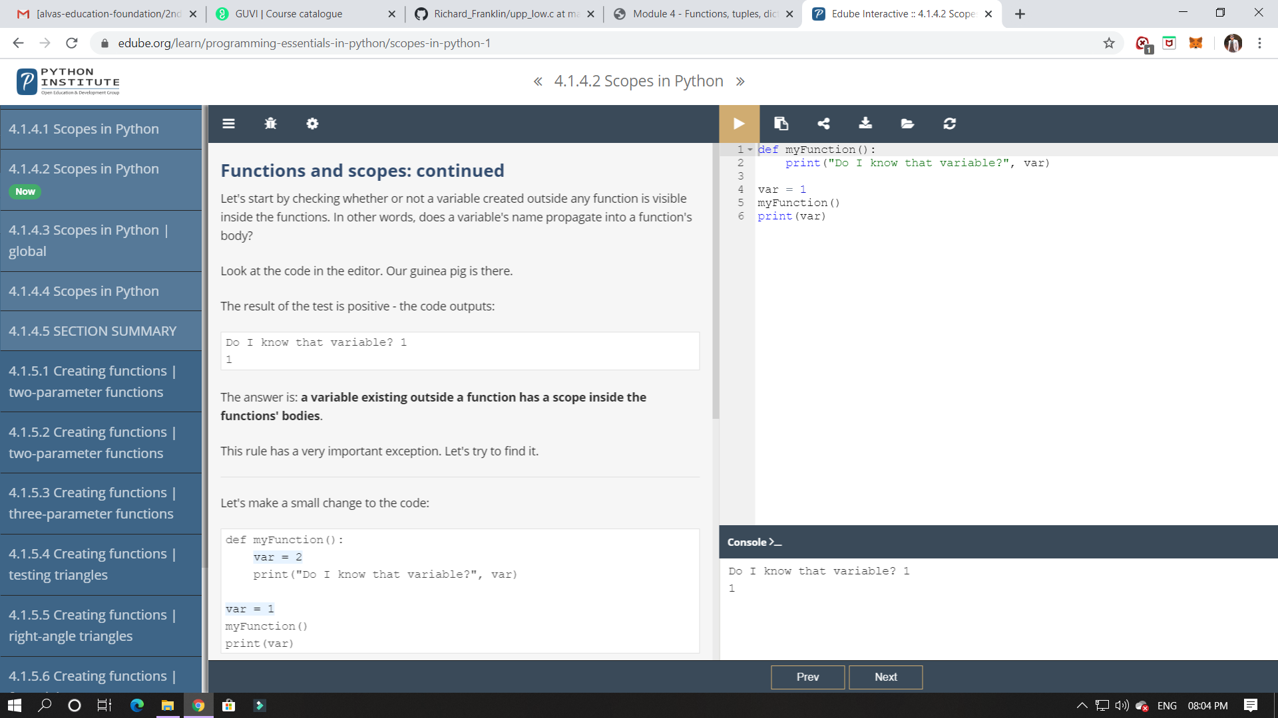

ONLINE CODING:

Write a C Program to count Uppercase, Lowercase, special character and numeric values for a given String

